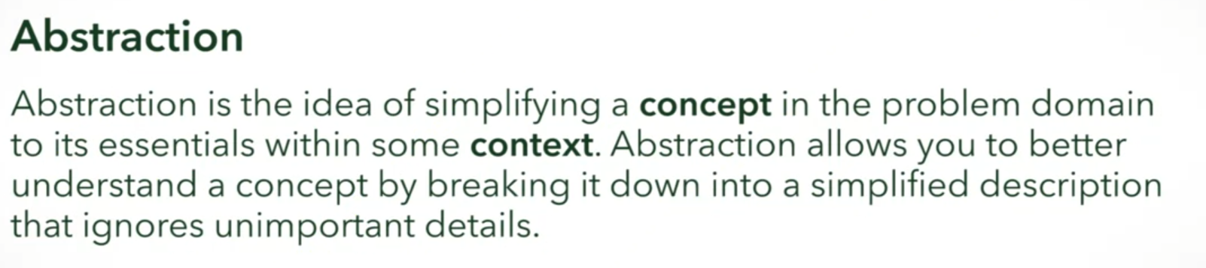

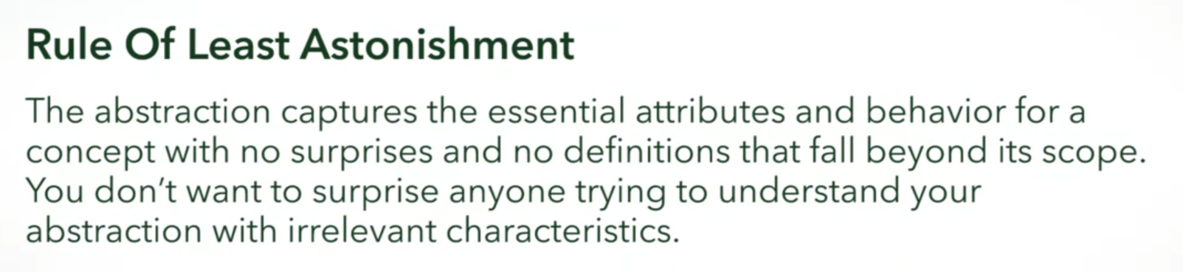

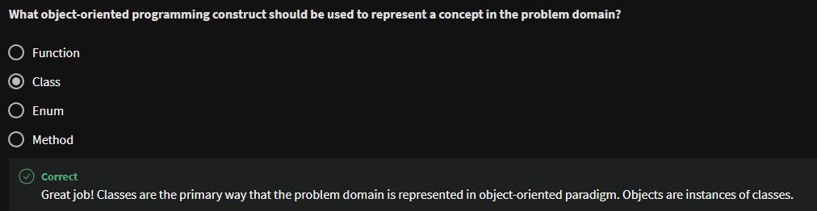



Student: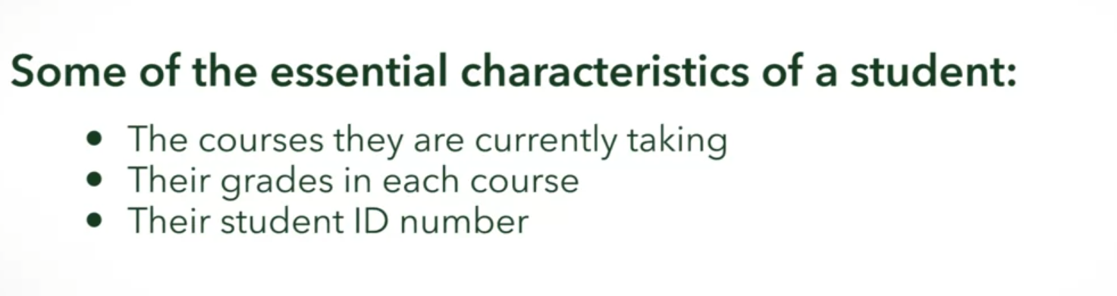

House Cat:

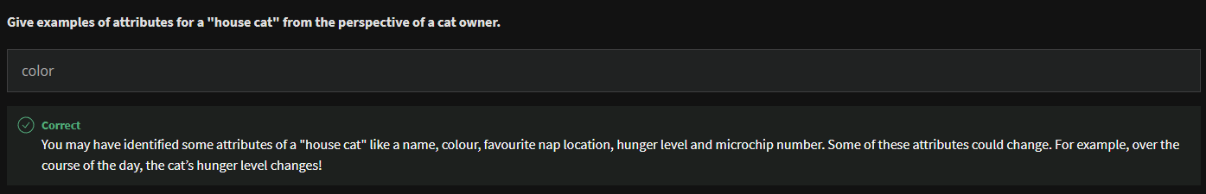

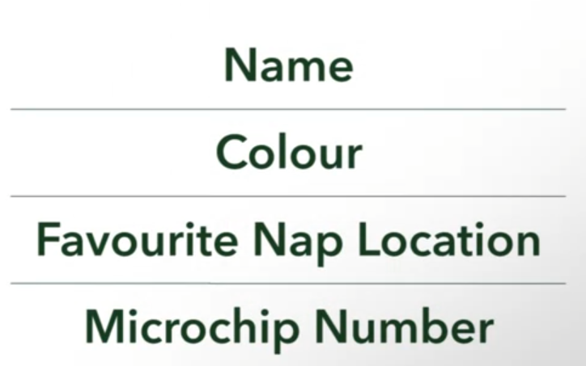



Student:

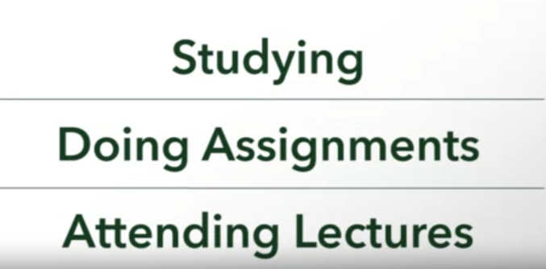

House Cat:

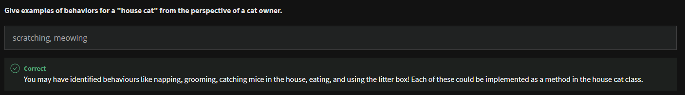

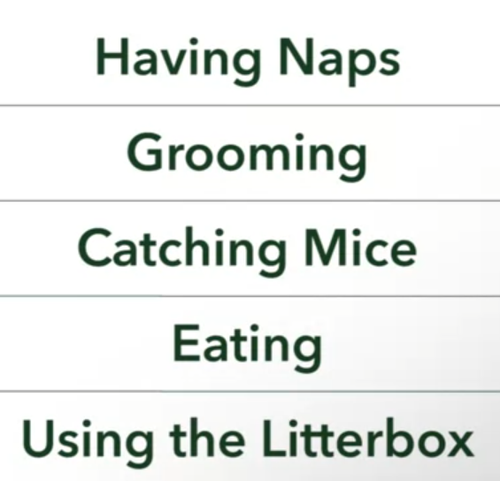

**Now try creating a dog abstraction for the software space! Remember to identify both attributes and behaviors.**

Attributes: name, color, favorite food Behaviors: playing, jumping, eating

Correct

Your abstraction may have identified attributes like the dog’s breed, its size, whether it has long or short hair, pointy or floppy ears, and its color. Behaviors of a dog include sleeping, eating, and doing tricks.